**Project 01:** Organizing & Visualizing a Dashboard using Looker studio.

**Dataset Overview**: In this project, a dashboard for BPL has been created using Looker Studio. There are three datasets: Batsmen, Bowlers and BPL.

Here are the datasets:

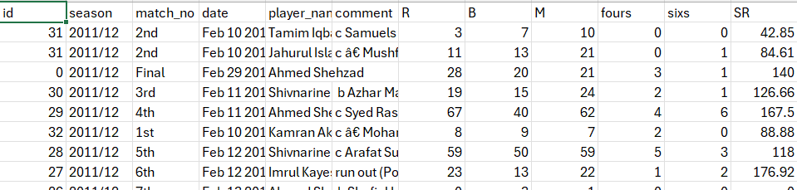

Dataset 01: Batsmen

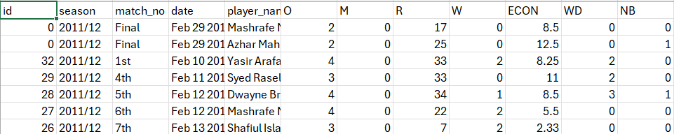

Dataset 02: Bowlers

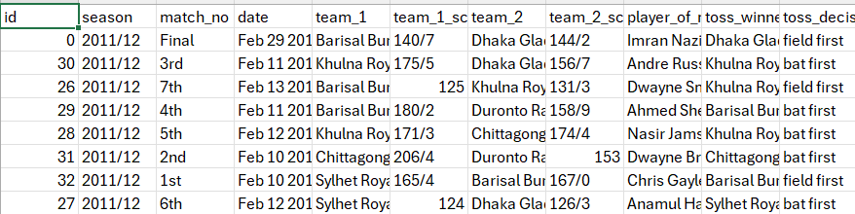

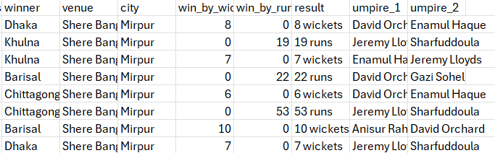

Dataset 03: BPL

Here is the Relationship between these tables:

Many-to-many

Many-to-many

Bowlers

BPL

Batsmen

**Dashboard Overview:**

[**https://lookerstudio.google.com/reporting/15168328-fac3-4da7-9356-cfd15d9dd5e3**](https://lookerstudio.google.com/reporting/15168328-fac3-4da7-9356-cfd15d9dd5e3)

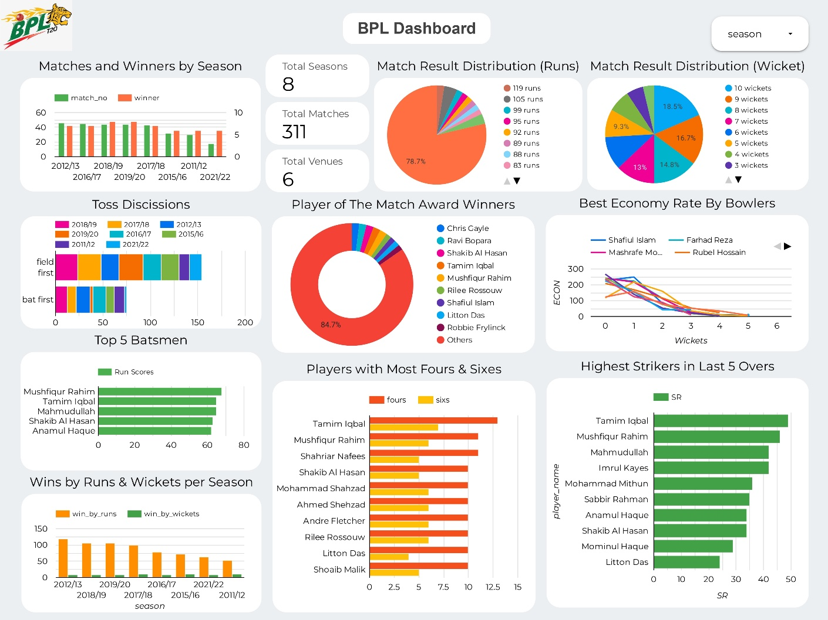

Fig: BPL Dashboard